

Dr. Cassandra, Brown inc.
2020-06-17
Dr. Brown
732 Hawkins Road, New Mandy, KS 44681
Phone: 3566365264
Fax: 4380005369

Re: Aimee, Khan
PHN: 6105288035
Birthdate: 18-Aug-2003
Address: 8178 Steven Knoll, Aaronstad, GA 03418
Patient number: 4899358406

To Whom It May Concern:

This is a medical letter to state the above patient is pregnant with expected delivery date of 02-Apr-2025. Hoping this information is satisfactory for your requirements.

Thank you.

Sincerely,
Dr. Cassandra, Brown
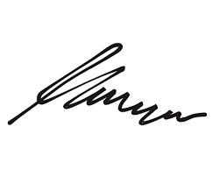
FRCS© NCMP
Clinical Assistant Professor, UBC
Department of Obstetrics and Gynecology SMH

